ODBCWriteNow User Manual

Contents
History 2
What is ODBCWriteNow? 3
How can ODBCWriteNow be used? 3
Step 1 – Registering with ODBCWriteNow 4
Step 2 – Authorizing with MYOB 6
Step 3 – Setting up the Company File 7
What Data can you Read/Write with ODBCWriteNow? 8
Syncing via the ODBCWriteNow Website 10
Upload Files Page 10
Upload Files Button 10
Drag and Drop Method 11
Results and Common Errors 11
Download Sync 12
Programming Examples 13
Reading MYOB Data 13
Additional Options and Paging 14
Additonal Options 14
Coding to get All records in a MYOB Table 15
URL Get Formats 16
Access Example 17
Importing Data into MYOB 20
VBA Upload Functions 20
VBA Upload Example 21
Upload Data Formats 22

History
Date | Who | What
17/8/2016 | matt@accede.com.au | Manual rewrite
6/9/2016 | matt@accede.com.au | Update with Changes and Screenshots
21/10/2016 | matt@accede.com.au | Update to upload and download sample coding
8/3/2017 | matt@accede.com.au | Minor editing and review
6/6/2018 | matt@accede.com.au | Updated with new sync tables information

What is ODBCWriteNow?
MYOB's new cloud based service offers an automatic API interface to replace the previous ODBC that they offered for their local based accounting system. Many companies used this ODBC service to automatically update their unique solutions, that they needed outside of the standard MYOB accounting solutions. However, with this move to an API, companies have found difficulties in cost, time or the necessary changes to allow access to their data via the API
ODBCWRITENOW is a great answer. It allows users to Read their data, write new records to their data, e.g. New Customers, Jobs or Service Orders, and to Edit their data.
ODBCWriteNow allows you or your programmer to use a simple trigger (e.g. Button, Macro, Scheduled task), to read, write and edit between MYOB and your alternate data (e.g. Excel, Access, MS SQL, MYSQL).
All the API work has been done for you. This solution, reads from a simple text based file and send back to a simple text based file all the MYOB data you have.
Now you have total access to your MYOB Cloud data, and you can use this data to give your company the edge it needs. With about 10 minutes’ setup time, you have access to your data. All you need to do is decide how you wish to use this.

How can ODBCWriteNow be used?
ODBCWriteNow has a variety of uses and really the only limit is your imagination. However, to help stir that imagination, here are some uses that clients are currently using ODBCWriteNow for:
- Graphic representation of your data in an interactive Excel spreadsheet - now you don’t have to import, export and setup. This spreadsheet can be real time.
- Service Technicians on site, don’t have a MYOB License, you don’t want them in MYOB, they use a simple web environment to record their work, times and changes, now, you can have this auto transfer to MYOB, live from the tech to on site.
- Checking the actual payment and invoice status of the jobs and work you are doing from your own database
- Creating Management and marketing reports based on sales, work and Invoices and Payments
- Having a simple customer portal, that they can see what they owe you without having them access your secure MYOB Data.
- Even using Google Maps to see, add and enter your data. This means your sales people can use their phones and via Google Maps see their history of sales, services etc. If you find this interesting, check out http://www.crm-map.com/
- Costs against a job or a customer’s purchase.
Really the list is only limited by your imagination.

Step 1 – Registering with ODBCWriteNow
The first step to using ODBCWriteNow is to register on the ODBCWriteNow Website and receive a ODBCWriteNow API Key. This API Key is the MOST CRITICAL part of ODBCWriteNow as it acts as both the login for the ODBCWriteNow Website and as authentication when making calls programmatically, Companies and Users should be very careful who has access to this API Key and be careful not to lost it.
To begin registration users must first go to the ODBCWriteNow website by visiting the following link: http://myobsync.accede.com.au/
This will show the ODBCWriteNow login page; shown below.
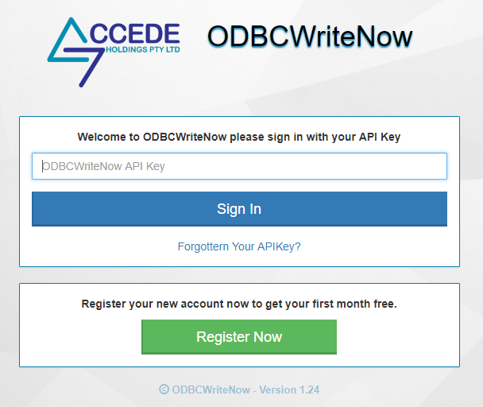
Once here click the “Register Now” button to reach the Registration form; shown below.
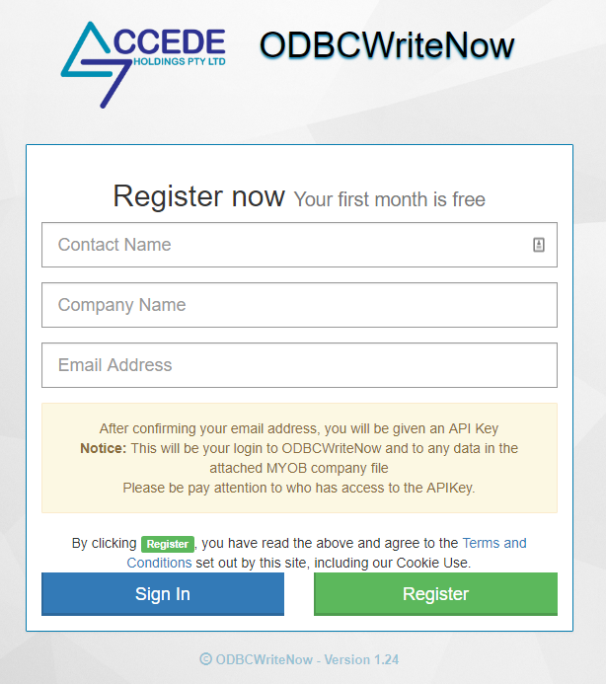
On this form fill the details for Contact Name, Company Name and Email Address, once you are happy with details press “Register” to continue.
Note –
- Each Email Address is linked to its ODBCWriteNow Account thus the same email address cannot be used for more than one ODBCWriteNow Account.
- By clicking the “Register” button you agree to the Terms and Conditions set out by ODBCWriteNow, including Cookie Use.
Once the “Register” button has been clicked a Confirmation Email will be sent to the Email address provided.
The confirmation email will contact a “Confirm” button, once this button has been pressed and the Email confirmed a second email will be sent containing your ODBCWriteNow API Key.
Note –
If the email containing the API Key does not arrive be sure to check the spam or junk folders of the provided email.
Once the API Key has arrived you can login to the ODBCWriteNow Website and continue the setup process.

Step 2 – Authorizing with MYOB
The next step for setting up ODBCWriteNow is to Authorise MYOB to allow ODBCWriteNow Access. To begin login to the ODBCWriteNow Website using the API Key generated during step 1.
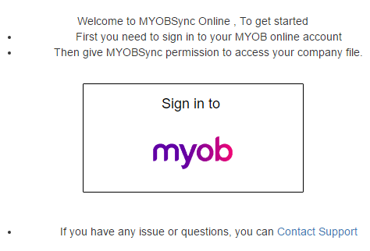
Shown above is the first time view of the ODBCWriteNow Setup page, to continue press the “Sign in to MYOB” button.
This will take you to the Official MYOB Login Page, shown below, here enter the Email Address and Password for your MYOB Online account and press “Sign in”, this will let MYOB know that you Authorise ODBCWriteNow to access your MYOB Online account’s data.
The MYOB Online account that you use here should be the MYOB account you wish to be making all the ODBCWriteNow inserts, edits and pulls.
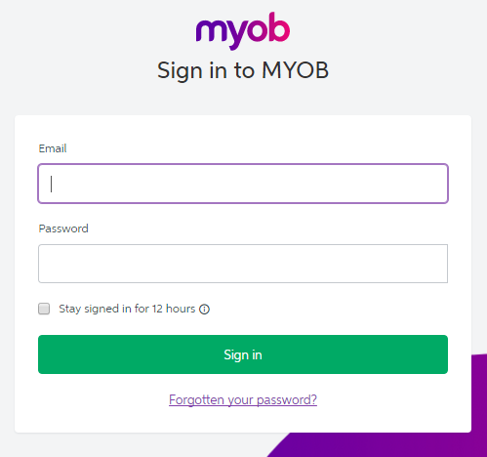

Step 3 – Setting up the Company File
Once MYOB has been authorised the setup page of the ODBCWriteNow website will be changed and new options will appear, shown below.
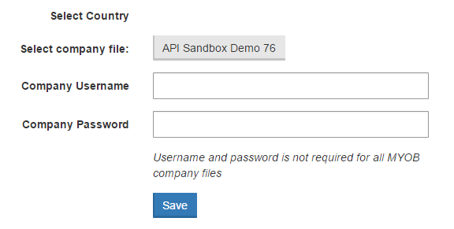
On these settings select the Company file you wish to read and write data from the available company files, these options are populated from information in your MYOB Online account, and enter a valid username and password for the selected Company file and press save.
Note –
If you are unsure of the name of your Company file or a valid username and password, you should speak to whoever handles the MYOB Company file for your company or check your MYOB online account.
Once the Company file, username and password have been saved more options will appear again in the ODBCWriteNow setup page as ODBCWriteNow begin to read some data from your MYOB file, shown below.
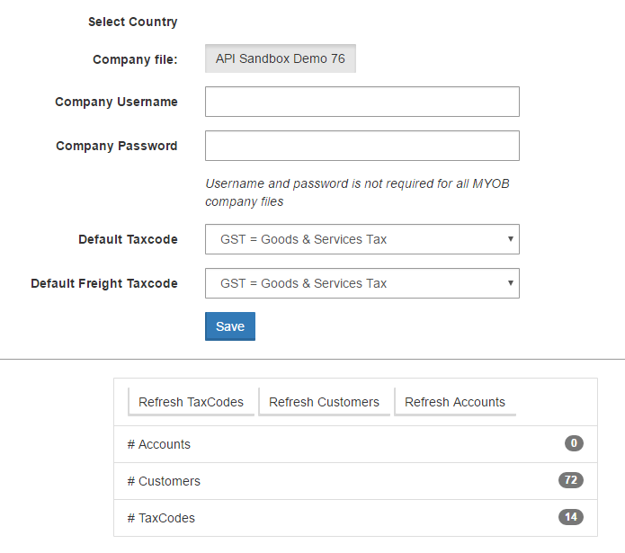
To finalize the setup of ODBCWriteNow, press the 3 refresh buttons which have appeared at the bottom of the MYOB Authentication section; these are “Refresh TaxCodes”, “Refresh Customers” and “Refresh Accounts”.
This will read information from the selected Company file for use in the setting area. The number of Customers and Accounts in the selected Company file will now appear in the bottom of the Authentication section, labelled “# Accounts”, “# Customers” and “# TaxCodes”.
The Default Tax Code and Default Freight Tax Code options can also now be used and are the tax codes that ODBCWriteNow will used when importing data to MYOB in the case that either is not specified by the data file.
Notes –
- Each ODBCWriteNow API key can only be linked to a single MYOB Company File at a time, if you want to link two Company Files at the same time you will need to register for a second ODBCWriteNow API Key.
This completes the basic setup of ODBCWriteNow and it can now be call programmatically to read or write data to the selected Company file. These settings can be changed at any time but only need to be setup once.

What Data can you Read/Write with ODBCWriteNow?
ODBCWriteNow can access the data for the following tables in MYOB Online allowing for reading and writing of data.
MYOB Online Table | MYOB ODBC Table | Read | Write | Edit
Customer | Customer Cards
Job | Jobs
Supplier | Supplier Cards
Service Order | Service Sales
Service Order Lines | Service Sales
Service Sales | Service Sales
Service Sales Lines | Service Sales
Service Purchase | Service Purchases
Service Purchase Lines | Service Purchases
Employee | Employee Cards
Products | Items
Transactions | Miscellaneous Sales
Sales Order | Miscellanceous Purchases
Customer Payments | Receive Payments
Customer Payment Lines | Receive Payments
Purchase Orders | Miscellanceous Purchases
Purchase Bill | Miscellaneous Sales
Service Bill | Service Sales
Service Bill Lines | Service Sales
Sales Order Item | Service Purchases
Sales Order Item Lines | Service Purchases
Sales Service Order | Service Sales
Sales Service Order Lines | Service Sales
Transaction Journal | Transaction Journal
Transaction Journal Lines | Transaction Journal Lines
Ledger Accounts | Ledger Accounts
Employee Payroll Details | Employee Payroll Details
Employee Timesheet | Employee Timesheet
Employee Timesheet Lines | Employee Timesheet Lines
Sales Invoice Items | Sales Invoice Items
Sales Invoice Item Lines | Sales Invoice Item Lines
Sales Invoice Time Billing | Sales Invoice Time Billing
Sales Invoice Time Billing | Sales Invoice Time Billing Lines
If there is a MYOB Online table that you need to sync and is not on this list, please contact us at: Support@accede.com.au as we are constantly expanding this list to meet demand.
You will note that Service Purchases and Service sales have write in some areas and not in others. AccountRight has different table layouts, where in MYOB Premier ODBC, it was purely a flag difference. This situation is the case in many areas of difference between the two products.

Syncing via the ODBCWriteNow Website
Uploading and download of data can be done both programmatically and via the ODBCWriteNow Website, this section will be describing the process for syncing via the ODBCWriteNow Website.

Upload Files Page
The upload files page can be reached by the “Upload Sync” link at the top of the page for all pages in the ODBCWriteNow Website.
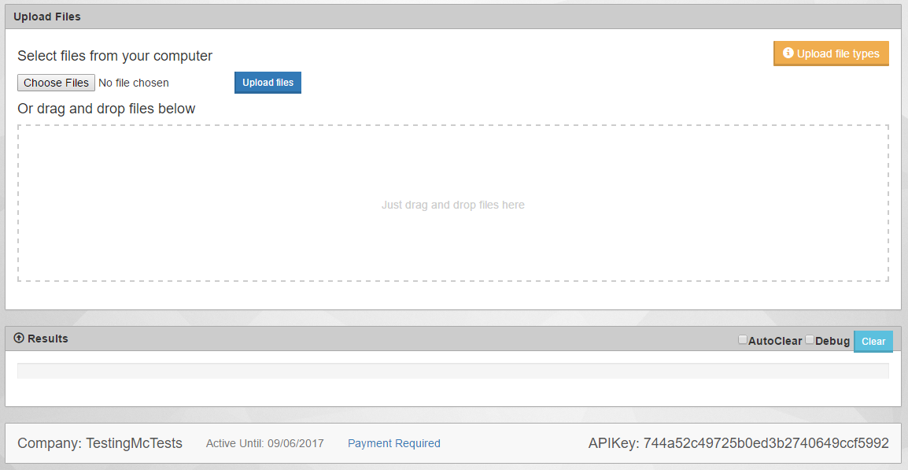
On this page are two methods for uploading file in the correct format, described in the Upload Formats section, these methods are the Upload files button and the drag and drop area.

Upload Files Button
To use the “Upload Files” button the user must first select the file they wish to upload by pressing the “Choose Files” button.
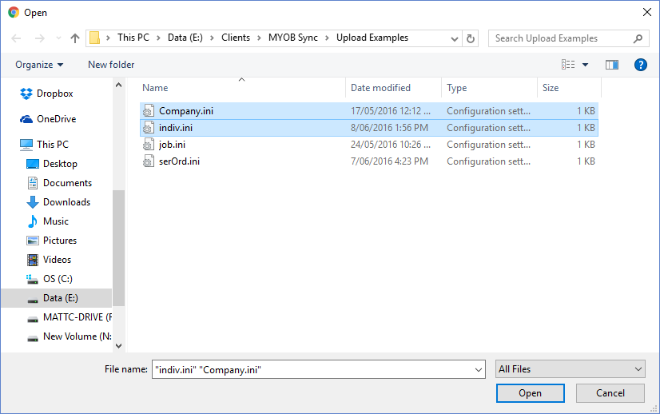
After pressing the “Choose Files” button a dialog window will appear where the user can select the file, or files, they wish to upload. Once the files have been chosen the user can then press the “Upload Files” button to upload the selected files to MYOB, a message then appear in the Results section detailing the results of the upload.

Drag and Drop Method
The second method for uploading via the ODBCWriteNow website is using the “Drag and Drop” area in the upload files page. Here the user simply needs to select and drag the files they wish to upload into the area and the ODBCWriteNow will attempt to upload the data in the files and output the results into the results area near the bottom of the page.

Results and Common Errors
The most common cause for an upload failing is missing or incorrect data in the files uploaded, when an upload fails the user should first check the data in the file that the results says failed. The following is a list of common error caused by missing or incorrect data and how to resolve them.
If the upload for either method, upload files button or drag and drop, was successful the message that displays in the results area will be as follows:
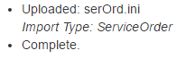
In the example about this was a successful upload of a new Service Order from the file serOrd.ini.
A common error that can occur when uploading job data is as follows:
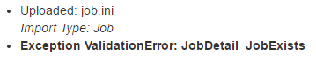
This error means that the job number set in the file data already exists in MYOB, for this error simple change the Number field for the Job.ini and try again.
In the case a required field is missing for the current type of import the following error will show:
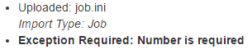
In the example above the Job did not have a Number=data line and the Number field is required for the upload.
When uploading a new Individual or Company into MYOB if a default tax code is not set and the file does not a tax code specified the following error will occur:
Another common error is the following error message: “The Company File version is not support”. This is a MYOB error message and generally mean that your version of Account right is out of date.

Download Sync
Pressing the “Download Sync” link on the top of any ODBCWriteNow page will go to the Download data page where the user can download the latest data from MYOB as either CSV format or JSON format.
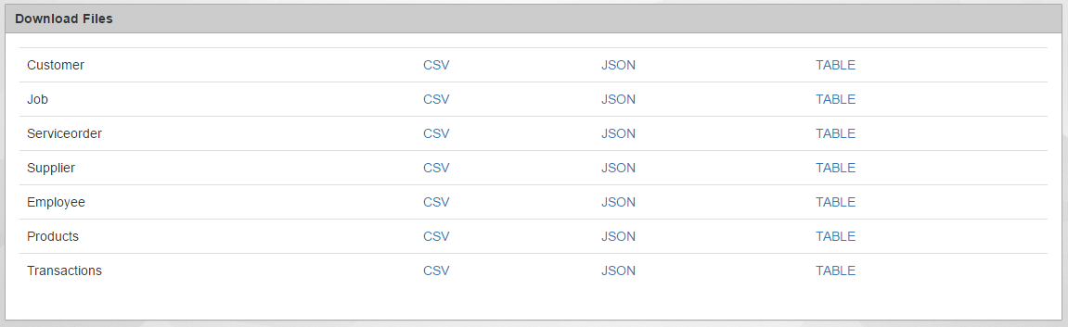
Pressing the CSV or JSON linking next to a MYOB Type will download a file of the selected format containing all the data from MYOB about that MYOB Type, for example pressing the CSV next to Supplier will download a CSV file containing all the Supplier data from the linked MYOB Company.
Pressing the Table link on the other hand will output the information directly to the browser window so that it can be instantly viewed.
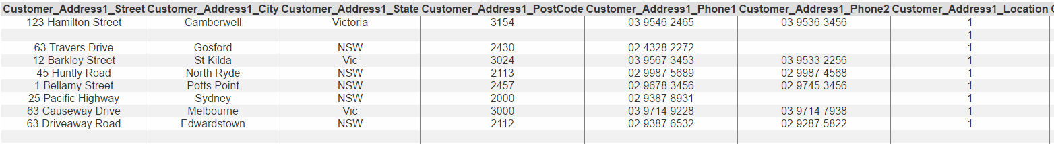

Programming Examples
ODBCWriteNow works by accepting various URL calls to the Website and then uploads or downloads the data from MYOB Online as needed. The following are Coding example on how to read and write data to the MYOB tables currently offered by ODBCWriteNow, these example are written in VBA but the URL calls are universal and will work with any programming language.

Reading MYOB Data
Reading MYOB data using ODBCWriteNow is simply a case of sending a GET request along with your ODBCWriteNow API Key to the correct URL for the data you want, ODBCWriteNow will then return that information in either CSV or JSON formats. Below is an example of a ODBCWriteNow URL, in the example below the data in the Job table from MYOB Online will be returned in a CSV format:
http://myobsync.accede.com.au/download/job/csv/0?onlyheader=1&apikey=[Company API Key Goes Here]
In the above example the highlighted section of the URL determines what table is import from MYOB and the output format.
In the Table on the next page are examples of what should replace this section if other data or formats are wanted. This list is also available on the ODBCWriteNow website along with links to the matching MYOB Developer information page about that table.

Additional Options and Paging
The MYOB Online API only returns a maximum of 1000 records per API call, to get around this ODBCWriteNow uses the Pages system.
The Pages system splits the total records for a MYOB table into pages of 400 records (the MYOB Default amount per request), for example requesting ODBCWriteNow to view the 3rd page will skip the first 800 records and get records 801 to 1200.
The Page value goes just after the Data format in the URL call, this value must be a whole Integer i.e 4,6,7. The Paging count starts from 0 so page 0 contains records 1-400 page 1 contains 401-800 etc. if this value is left blank ODBCWriteNow returns page 0.

Additonal Options
Currently in ODBCWriteNow there are two additional options when making URL calls, [onlyheader] and [datefrom].
[onlyheader] Allows users to request only the table headings for the selected MYOB table without any records, this can be used to review the MYOB table name or confirm that a value is located in the selected MYOB table.
[onlyheader] can be used by including "onlyheader=1" at the end of a URL call, as shown below.
http://myobsync.accede.com.au/download/job/csv/0?onlyheader=1&apikey=[YourAPIkey]
[datefrom] allows users to specify a certain date that they want to recieve records from. When [datefrom] is added to a URL call ODBCWriteNow will ONLY return records with dates AFTER the given date.
[datefrom] will have not effect if the called MYOB table does not have a valid date field, e.g. the Customers table.
[datefrom] can be used by including "datefrom=2016-12-30" at the end of a URL call, as shown below.
http://myobsync.accede.com.au/download/job/csv/0?datefrom=2016-12-30&apikey=[YourAPIkey]

Coding to get All records in a MYOB Table
As mentioned above because of the MYOB API's record limit it is not possible to pull down all records within a MYOB table in one URL call. To get all the records using ODBCWriteNow it is necessary to loop through URL calls until you recive a page with no records. Examples of how to do this are shown below, these examples have been made as stand alone functions and should work with minimal changes mean you can copy and paste the function into your software and use it by simply calling it:
Public Function DownloadAndImport(what As String, tablename As String, Secification As String) As String
Dim data As String
Dim page As Integer
Dim fs As Object ''FileSystemObject
Dim tsOut As Object ''TextStream

'Your Company's API Key goes below
apikey = ""
server = "http://myobsync.accede.com.au/"

page = 0
lastPage = False

'download the complete file first

Set fs = CreateObject("Scripting.FileSystemObject")
tempFileName = "C:\windows\temp\myobsynctemp_" & tablename & ".csv"
Set tsOut = fs.CreateTextFile(tempFileName, True)

MsgBox server & "download/" & what & "/" & page & "?onlyheader=0&apikey=" & apikey
End

'Get Header Row
data = ServerRequest("GET", server & "download/" & what & "/" & page & "?onlyheader=1&apikey=" & apikey, "")
If InStr(data, "MYOBSync Error") <> 0 Then
lastPage = True
Else
tsOut.WriteLine data
End If

'Get csv data
While lastPage = False
SysCmd acSysCmdSetStatus, "Downloading To file " & what & ", Page " & page

data = ServerRequest("GET", server & "download/" & what & "/" & page & "?onlyheader=0&apikey=" & apikey, "")

'Check for a MYOBSync Error, meaning it has returned no records
If InStr(data, "MYOBSync Error") <> 0 Then
lastPage = True
Else
tsOut.WriteLine data
page = page + 1
End If
DoEvents
Wend

tsOut.Close

'Import CSV Data into table
SysCmd acSysCmdSetStatus, "Importing File " & what & " to table " & tablename & ", Page " & page
DoCmd.TransferText acImportDelim, Secification, tablename, tempFileName, True

SetAttr tempFileName, vbNormal
' Kill tempFileName

SysCmd acSysCmdClearStatus
End Function

URL Get Formats

MYOB Online Table | Download in CSV Format | Download in JSON Format
Job | Job/csv | Job/json
Customer | Customer/csv | Customer/ json
Service Order | Serviceorder/csv | Serviceorder/ json
Service Order Lines | service_order_lines/csv | service_order_lines/ json
Supplier | Supplier/csv | Supplier/ json
Employee | Employee/csv | Employee/ json
Product | Products/csv | Products/ json
Transaction | Transactions/csv | Transactions/ json
Sales Order | Sales_order/csv | Sales_order/ json
Customer Payment | Customer_payments/csv | Customer_payments/ json
Customer Payment Lines | Customer_payments_lines/csv | Customer_payments_lines/ json
Service Sale | Service_sales/csv | Service_sales/ json
Service Sale Lines | Service_sales_lines/csv | Service_sales_lines/ json
Purchase Order | Purchase_orders/csv | Purchase_orders/ json
Purchase Bill | Purchase_bills/csv | Purchase_bills/ json
Service Bill | Service_bills/csv | Service_bills/ json
Service Bill Lines | Service_bill_lines/csv | Service_bill_lines/ json
Sales Invoice | Sales_invoice/csv | Sales_invoice/ json
Sales Order Item | Sales_order_item/csv | Sales_order_item/ json
Sales Order Item Lines | Sales_order_item_lines/csv | Sales_order_item_lines/ json
Service Purchase | Service_purchase/csv | Service_purchase/ json
Service Purchase Lines | Service_purchase_lines/csv | Service_purchase_lines/ json
Sales Service Order | Sales_service_order/csv | Sales_service_order/ json
Sales Service Order Lines | Sales_service_order_lines/csv | Sales_service_order_lines/ json
Employee Payroll Details | Employee_timesheet/csv | Employee_timesheet /json
Employee Timesheet | employee_payroll_details/csv | employee_payroll_details/json
Employee Timesheet Lines | employee_timesheet_lines/csv | employee_timesheet_lines/json
Sales Invoice Item | sales_invoice_item/csv | sales_invoice_item/ json
Sales Invoice Item Lines | sales_invoice_item_lines/csv | sales_invoice_item_lines/json
Sales Invoice Time Billing | sales_invoice_time_billing /csv | sales_invoice_time_billing /json
Sales Invoice Time Billing Lines | sales_invoice_time_billing_lines/csv | sales_invoice_time_billing_lines/json

Access Example
Public Function DownloadAndImport(what As String, tablename As String, Secification As String, DateFrom As Date) As String
Dim data As String
Dim page As Integer
Dim fs As Object ''FileSystemObject
Dim tsOut As Object ''TextStream

apikey = [Company API Key goes Here]
server = "http://myobsync.accede.com.au/"

page = 0
lastPage = False

datefromstr = ""
If Not DateFrom = 0 Then
datefromstr = "&datefrom=" & Format(DateFrom, "yyyy-mm-dd")
End If

'donwload the complete file first

Set fs = CreateObject("Scripting.FileSystemObject")
tempFileName = "C:\windows\temp\myobsynctemp_" & tablename & ".csv"
Set tsOut = fs.CreateTextFile(tempFileName, True)

'Get Header Row
data = ServerRequest("GET", server & "download/" & what & "/" & page & "?onlyheader=1&apikey=" & apikey & datefromstr, "")
If InStr(data, "MYOBSync Error") <> 0 Then
lastPage = True
Else
tsOut.WriteLine data
End If

'Get csv data
While lastPage = False
SysCmd acSysCmdSetStatus, "Downloading To file " & what & ", Page " & page

data = ServerRequest("GET", server & "download/" & what & "/" & page & "?onlyheader=0&apikey=" & apikey & datefromstr, "")

If InStr(data, "MYOBSync Error") <> 0 Then
lastPage = True
Else
tsOut.WriteLine data
page = page + 1
End If
DoEvents
Wend

tsOut.Close

'Import CSV Data into table
SysCmd acSysCmdSetStatus, "Importing File " & what & " to table " & tablename & ", Page " & page
DoCmd.TransferText acImportDelim, Secification, tablename, tempFileName, True

SetAttr tempFileName, vbNormal
' Kill tempFileName

SysCmd acSysCmdClearStatus
End Function

Public Function encodeURL(str As String)
Dim ScriptEngine As Object
Dim encoded As String

Set ScriptEngine = CreateObject("scriptcontrol")
ScriptEngine.Language = "JScript"

encoded = ScriptEngine.Run("encodeURIComponent", str)

encodeURL = encoded
End Function

Public Function ServerRequest(method As String, url As String, data As String)
Debug.Print url
Debug.Print data

Dim objHttp As Object
Set xmlhttp = CreateObject("Msxml2.XMLHTTP")
xmlhttp.Open method, url, False
xmlhttp.setRequestHeader "Content-Type", "application/x-www-form-urlencoded"
If Not data = "" Then
data = encodeURL(data)
xmlhttp.Send "&data=" & data
Else
xmlhttp.Send
End If

ServerRequest = xmlhttp.responseText
Set objHttp = Nothing
End Function

In the Above example is a series of access functions that are setup to download information from MYOB Online using ODBCWriteNow.
The example above works send constructing a URL and sending a get request, the URL then returns the data in the specified format and the code generates a temporary txt file with the data which is then imported into Access using a pre-made Access import specification. Below is an example of a generated URL:
http://myobsync.accede.com.au/download/job/csv/0?onlyheader=1&apikey=[Company API Key Goes Here]
The above functions can be copied directly into any existing MS Access program, once copied the developer will need to replace the highlight area of the code with their company’s unique ODBCWriteNow API Key.
Once setup the above functions can be called anywhere in access with a line of code similar to the below:
DownloadAndImport "job/csv", "MYOX_Jobs", "MYOX_Jobs", DateFrom
This function uses 3 required parameters and 1 optional, in order they are MYOB Data target, Import Table, Import Specification, Date from.
- The MYOB Data target is the MYOB Online table that you want to download as well as the file format that data should be in. Examples of how these should be formatted for each table in shown in the example below.
- The Import table is the name of the MS Access Table that you want to import the data into.
- The Import specification is the MS Access Import specification that Access will try and use to correctly import the data. Provided below is a URL to an official Microsoft guide on how to create an import specification in access.
https://support.office.com/en-us/article/Save-the-details-of-an-import-or-export-operation-as-a-specification-6b94e183-2b10-4333-a31a-001fe75321b5
- The final optional parameter is the date from; these will tell ODBCWriteNow that you only want the data since the giving date.

Reading MYOB data using ODBCWriteNow is simply a case of sending a GET request along with your ODBCWriteNow API Key to the correct URL for the data you want, ODBCWriteNow will then return that information in either CSV or JSON formats. Below are examples of getting data from each currently possible table in ODBCWriteNow.

Importing Data into MYOB
Importing data into MYOB uses only one URL and instead uses a field in the import file to sort where the data should be imported to. Each will also provide a link to the official MYOB online API help pages which goes into great details about each field within the format.

VBA Upload Functions
Below are example VBA functions for the uploading of data into ODBCWriteNow. These functions can be copied into any existing VBA based application (MS Access, MS Excel etc.) but the company’s unique ODBCWriteNow API key must be put in the highlighted section.

Public Function PostChange(str As String)
Debug.Print "================="
Server = "http://myobsync.accede.com.au/"
apikey = [Company API Key]
serverPost = ServerRequest("POST", Server & "sync/post" & "?apikey=" & apikey & "", str)
Debug.Print serverPost
Debug.Print "================="
PostChange = serverPost

End Function

Public Function encodeURL(str As String)
Dim ScriptEngine As Object
Dim encoded As String

Set ScriptEngine = CreateObject("scriptcontrol")
ScriptEngine.Language = "JScript"

encoded = ScriptEngine.Run("encodeURIComponent", str)

encodeURL = encoded
End Function

Public Function ServerRequest(method As String, url As String, data As String)

Dim objHttp As Object
Debug.Print "URL:" & url

Set xmlhttp = CreateObject("Msxml2.XMLHTTP")
xmlhttp.Open method, url, False
xmlhttp.setRequestHeader "Content-Type", "application/x-www-form-urlencoded"
Debug.Print data
data = encodeURL(data)
Debug.Print data

xmlhttp.Send "&data=" & data

ServerRequest = xmlhttp.responseText
Set objHttp = Nothing

End Function

VBA Upload Example
To use the provided functions on the pervious page the use data must first be formatted into a way that ODBCWriteNow can understand. In the example below the information is formatted for the import of Job data into MYOB Online.
Dim SQL As String, vno As Integer

SQL = "Style=Job" & vbCrLf
SQL = SQL & "Number=" & Forms![Orders].[ContractNo] & vbCrLf
SQL = SQL & "Name=" & Forms![Orders].[Surname] & ", " & Forms![Orders].[GivenName] & vbCrLf
SQL = SQL & "Header=D" & vbCrLf
SQL = SQL & "Description=" & Forms![Orders].[Surname] & ", " & Forms![Orders].[GivenName] & vbCrLf
SQL = SQL & "Startdate=" & DatePart("d", Date) & "/" & DatePart("M", Date) & "/" & DatePart("yyyy", Date) & vbCrLf

res = PostChange(SQL)

vno = MsgBox("Job transfer " & res, vbOKOnly, "Transfer Complete")
The above example will format the information like so:
Style=Job
Number=65579
Name=Accede
Header=D
Description=Test2
Startdate=4/5/2016

Upload Data Formats
Listed below are the various data formats that data needs to be formatting in to properly upload using ODBCWriteNow. These file formats can also be found on the ODBCWriteNow Website on the file types page. Note that only fields marked as (Required) are required all other fields are optional. Each example also links to the official MYOB API developer page for that table.

Cards
In ODBCWriteNow Card uploads are separated into Individual and Company, examples of both are shown below.

Individual
Here is the file format required for importing an individual as a new customer in MYOB.
http://developer.myob.com/api/accountright/v2/contact/customer/
Style=Indivual (Required)
Lastname=Hill4 (Required)
Firstname=Craig4 (Required)
Street=104A Gibson St
City=Bowden
State=SA
Postcode=5007
Phone1=
Phone2=0401297505
Notes=Test Customer
CurrentBalance=1000
UseCustomerTaxCode=True
Label=AZZ
Lvalue=B

SaleLayout=Service
PrintedForm=Test Form
InvoiceDelivery=Nothing
ItemPriceLevel=Level A
ReceiptMemo=Testing Memo
ShippingMethod=Air
SaleComment=This is a testing comment
HourlyBillingRate=10
ABN=45 676 343 223
ABNBranch=014
TaxIdNumber=5555
Memo=Test Memo
PaymentIsDue=PrePaid
DiscountDate=10
BalanceDueDate=50
DiscountForEarlyPayment=25
MonthlyChargeForLatePayment=30
VolumeDiscount=0
Limit=1000
Available=1000
PastDue=0
OnHold=False

Method=Visa
CardNumber=1234
NameOnCard=Matthew Cogswell
BSBNumber=
BankAccountNumber=98765
BankAccountName=Matt's Account
Notes=This is a test Card

Company
Here is the file format required for importing a Company as a new customer in MYOB.
http://developer.myob.com/api/accountright/v2/contact/customer/
Style=Company (Required)
Companyname=Accede (Required)
Street=104A Gibson St
City=Bowden
State=SA
Postcode=5007
Phone1=
Phone2=0401297505
Notes=Test Customer
CurrentBalance=1000
UseCustomerTaxCode=True
Label=AZZ
Lvalue=B

SaleLayout=Service
PrintedForm=Test Form
InvoiceDelivery=Nothing
ItemPriceLevel=Level A
ReceiptMemo=Testing Memo
ShippingMethod=Air
SaleComment=This is a testing comment
HourlyBillingRate=10
ABN=45 676 343 223
ABNBranch=014
TaxIdNumber=5555
Memo=Test Memo
PaymentIsDue=PrePaid
DiscountDate=10
BalanceDueDate=50
DiscountForEarlyPayment=25
MonthlyChargeForLatePayment=30
VolumeDiscount=0
Limit=1000
Available=1000
PastDue=0
OnHold=False

Method=Visa
CardNumber=1234
NameOnCard=Matthew Cogswell
BSBNumber=
BankAccountNumber=98765
BankAccountName=Matt's Account
Notes=This is a test Card

Job
Here is the file format required for importing a new Job into MYOB.
http://developer.myob.com/api/accountright/v2/generalledger/job/
Style=Job (Required)
Number=65579 (Required)
Name=Accede
Header=D
Description=Test2
Startdate=4/5/2016
FinishDate=24/5/2016
JobName=Testing Job
Contact=Matthew Cogswell
Manager=Chris Chase
PercentComplete=50
IsActive=False
TrackReimbursables=True

Service Order
Here is the file format required for importing a new Service Order into MYOB.
http://developer.myob.com/api/accountright/v2/sale/order/order_service/
Style=ServiceOrder (Required)
CompanyName=Hill, Craig (Required)
CustomersNumber=62130 (Required)
Date=4/5/2016 (Required)
JobNumber=62130 (Required)
Description=Guttering as per Contract No UG62129 (Required)
AccountDisplayID=4-0100 (Required)
Taxcode=GST (Required)
IsTaxInclusive=True (Required)
Total=3324.56 (Required)
Freight=500
FreightTaxCode=GST
Comment=Testing Comment
PromisedDate=20/5/2016
ShippingMethod=Air
ReferralSource=Advertisement
JournalMemo=Sale; New Fields Test
DeliveryStatus=PrintAndEmail
PaymentIsDue=PrePaid
DiscountDate=1
BalanceDueDate=30
DiscountForEarlyPayment=5
MonthlyChargeForLatePayment=7
DiscountExpiryDate=7/06/2016
Discount=5
DueDate=7/06/2016
FinanceCharge=6.08

Supplier
Here is the file format required for importing a new Supplier into MYOB.
http://developer.myob.com/api/accountright/v2/contact/supplier/
Style=Supplier (Required)
Companyname=Accede Holdings (Required)
ABN=12345678910
Street=6 Zinfadel Ave
City=WYNN VALE
State=SA
Postcode=5127
Phone1=
Phone2=

Service Purchase
Here is the file format required for importing a new Service Purchase into MYOB.
http://developer.myob.com/api/accountright/v2/purchase/bill/bill_service/
Style=ServicePurchase (Required)
Date=2/10/2016 (Required)
CompanyName=Cash Purchases (Required)
InvoiceNumber=01027884
IsTaxInclusive=TRUE
SupplierNumber=738
FreightTaxcode=GST
JobNumber=IML611785
Description=""
AccountDisplayID=5-6552
Taxcode=GST
Total=709.5

Service Sale
Here is the file format required for importing a new Service Sale into MYOB.
http://developer.myob.com/api/accountright/v2/sale/invoice/invoice_service/
Style=ServiceSales (Required)
Date=30/9/2016 (Required)
CompanyName=Accede (Required)
InvoiceNumber=01013734
IsTaxInclusive=TRUE
CustomersNumber=1013734
SalesPersonName= Cogswell, Matthew
JobNumber=IDO611816
Description="Test Description"
AccountDisplayID=4-1000
Taxcode=GST
Total=8100

